+91 9965552513



1 77777 66666



Nowneesh T

Nowneesh123@gmail.com

www.linkedin.com/in/nowneesh



Business Analyst

Erode, TamilNadu



[Nown_Creation](https://sdgjekxzr/)

SUMMARY

To work in an environment where I can utilize and sharpen my skills and be able to contribute to the progress of the organisation and the society at large

TECHNICAL SKILLS

Programming languages: Java, Javascript, NodeJS, C++ Web Technologies:

HTML5, CSS

Data Modelling:

XML

Data Management:

MySQL, MongoDB, Scala Platforms:

Linux, Windows, Cybersecurity tools

Like Nmap, Metasploit

CERTIFICATIONS

Network security and database vulnerability | Coursera

Excel Essential Training | LinkedIn

POWER SKILLS

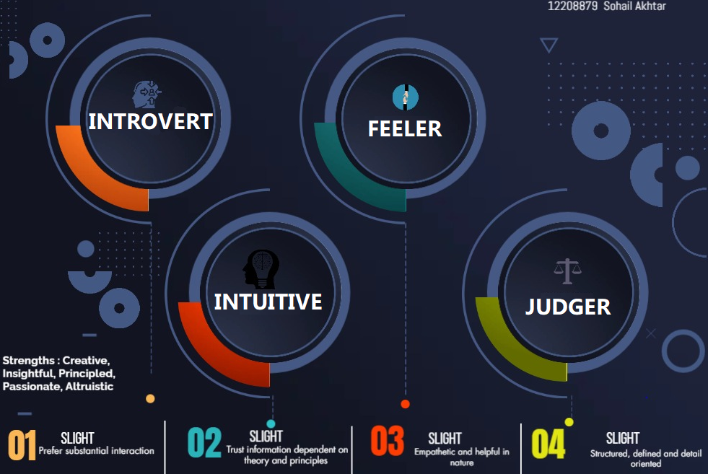

EXTRA CURRICULAR ACTIVITIES

Coding Event | Coding Club | Oct21

Mr and Ms. Detective | Android Club | Sep21

PROJECTS

Alumni Application Sep'20

Domain: Android Application| Programming Languages: Java, Php, Python Constructed an application to make a relationship between Alumnus

Developed features for the application and created a static pages to

enhance App experience.

Utilized Xml to create a new unique templates to create pages.

Bitcoin Price Prediction Aug'21

Domain: Python | Programming Languages: Python Built a script for finding the price of Bitcoin using python and created a own dataset for this project.

Bitcoin which is a well-known cryptocurrency in recent days.

We developed a set of code to increase accuracy of price prediction.

DeepFake Detection Feb'22

Domain: Python | Programming Languages: Python Built a script for finding the deepfake using python and took a suitable dataset available in Kaggle.

Deepfake is a technology to detect fake faces.

We developed a set of code to increase accuracy of detection of fake faces.

ACHIEVEMENTS

Secure 2nd position in paper presentation on the topic of Jan '20 - Mar '20

“Future of AI ”

Top 25 Rank in coding Event Feb '21 - Apr '21

EDUCATION

MBA in Financial Markets and Business Analytics Apr '22 - Present Lovely Professional University | Phagwara, IN

CGPA 8.2

B.E in Computer Science Jun '18 - Mar '22

Kongu Engineering College |Erode, IN CGPA 8.5